**Module (JQuery Basic, Effects & Advanced) – 5**

1. **What is jQuery?**

**Ans:** jQuery is a JavaScript library. It simplifies things like HTML document traversal and manipulation, event handling, and animation for web development. jQuery is open-source software and is widely used by developers to enhance the functionality.

1. **How to Apply CSS Using JQuery, How to Add Class and Remove Class in Jquery , JQuery Animation?**

**Ans: Applying CSS Using jQuery:**Here is a example:-

In this example, the jQuery css() method is used to set the text color and font size of the element with the ID “myid”.

**Input:**

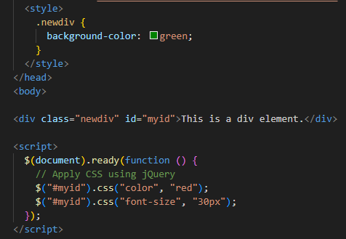

**Output:**



**Adding and Removing Classes:**

To add and remove classes using jQuery, you can use the addClass() and removeClass() methods:

**Adding class Example:-**

**Input:**

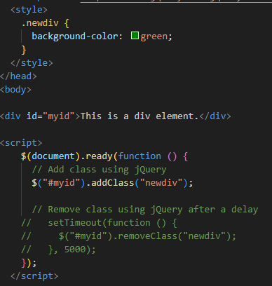

**output:**

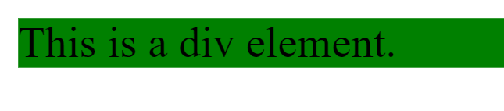

**Remove class Example:- input**

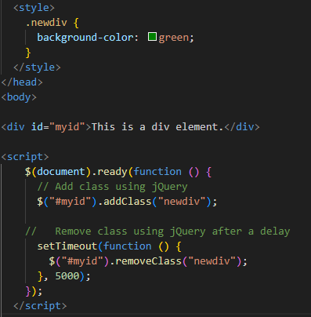

**Output:**

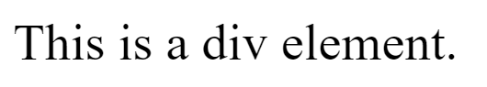

**Animation:**

**Input:**

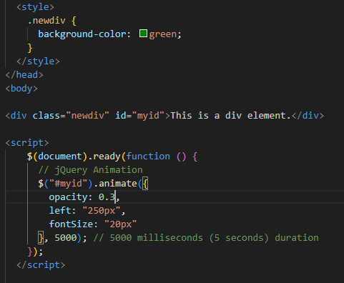

**Output:** After 5 sec result is showing like below

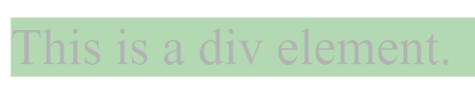

1. **How to create slider with animation?**

**Ans:**You can use jQuery's slideUp() and slideDown() functions to create a slide-up and slide-down effect, with animation.

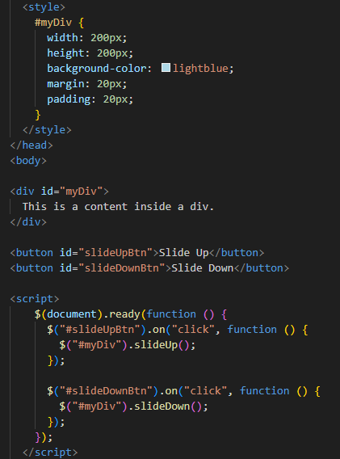

The slideUp() function is applied when the "Slide Up" button is clicked.

The slideDown() function is applied when the "Slide Down" button is clicked.

Adjust the styles, content, and animation duration as needed for your specific use case. The slideUp() and slideDown() functions include an optional duration parameter that specifies the animation duration in milliseconds. If not provided, a default duration is used.